- \Operation\Strip transfer, unit D\Strip infeed
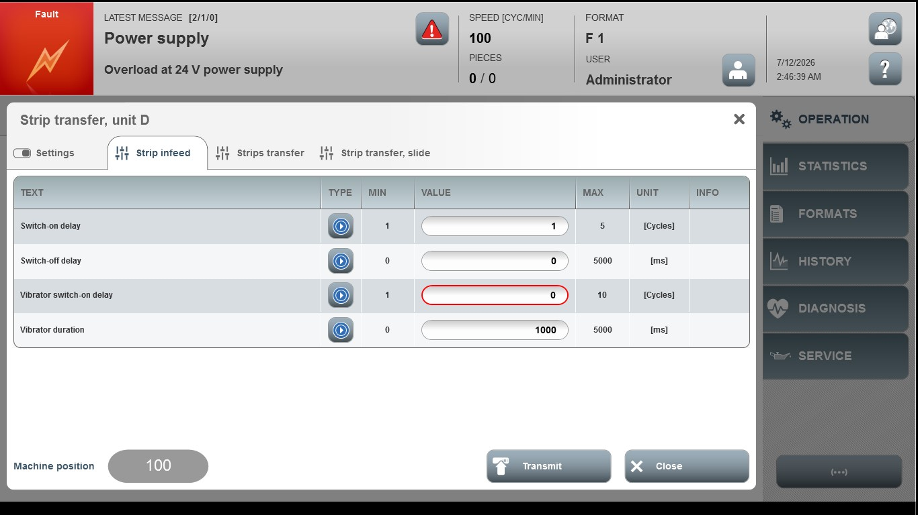

Acceptance criterion | Limits | Pass / Fail: Dev-No. | Date | Initials
Screen matches screenshot | N / A
Switch-on delay | 1 … 5
Switch-off delay | 0 … 5000
Vibrator switch-on delay | 1 … 10
Vibrator duration | 0 … 5000

